PREDICTIVE MAINTENANCE USING MULTI MODEL

Research / Development based Project

Phase II
Synopsis

MCA (Data Science)
Semester II
Submitted by

ALEXANDRA PRATAP SINGH
Batch year: 2022-2027 Enrolment No: U2245002

Project Guide – Ms. SUNITA TRIPATHI


Centre of Computer Education & Training Institute of Professional Studies
University of Allahabad, Prayagraj
Uttar Pradesh – 211002
TABLE OF CONTENT

Sr. No. | Contents | Page No.
1 | Introduction | i-iii
 | 1.1 Problem Definition
 | 1.2 Motivation
2 | Objective | iv
3 | Requirement Analysis and Specification | v-vi
 | 3.1 Functional Requirements
 | 3.2 Non-Functional Requirements
 | 3.3 Hardware and Software Requirements
4 | System design DFD (Data Flow Diagram) | vii
5 | Algorithm Used | viii
6 | Milestone | ix
7 | Meeting With Supervisor | x
8 | Reference | xi

- INTRODUCTION

Project Title: Predictive Maintenance using multi-model
Category: Machine Learning
The Predictive Maintenance System is a data-driven solution designed to anticipate machine failures before they occur by analysing operational parameters and sensor measurements collected from industrial equipment. By leveraging historical machine data such as temperature, rotational speed, torque, and tool wear, the system predicts whether a machine is likely to fail and identifies the type of failure. This proactive approach enables industries to transition from reactive maintenance strategies to intelligent, condition-based maintenance planning.
Using advanced techniques such as data preprocessing, feature engineering, class imbalance handling, and supervised machine learning algorithms including Logistic Regression, K-Nearest Neighbours, Support Vector Machine, Random Forest, and XGBoost, the system evaluates machine health with high accuracy. It incorporates model comparison and performance metrics such as Accuracy, ROC-AUC, F1-score, and F2-score to ensure reliable and interpretable predictions. Additionally, dimensionality reduction and visualization techniques are applied to better understand feature contributions and decision boundaries.
Predictive maintenance systems play a crucial role in Industry 4.0 environments, enabling organizations to reduce unexpected downtime, optimize maintenance costs, and extend equipment lifespan. By providing data-driven insights into machine behaviour and failure mechanisms, the Predictive Maintenance System supports efficient resource allocation and enhances operational reliability, making it a valuable asset in modern manufacturing and industrial operations.

1.1 Problem Definition
The increasing adoption of predictive maintenance across industrial sectors has created challenges in accurately predicting machine failures and ensuring reliable maintenance decision-making. Traditional maintenance approaches and many existing research studies rely on limited modelling strategies, leading to inconsistent performance, poor failure detection, and reduced industrial trust in AI-driven systems. Despite advancements in machine learning, several methodological gaps remain in current predictive maintenance implementations.
- Single-Model Dependency Problem: Many existing studies depend on a single algorithm such as Random Forest or SVM without performing structured multi-model comparison. This limits robustness, benchmarking clarity, and model generalizability across different operational conditions. The absence of comparative evaluation makes it difficult to identify the most suitable algorithm for deployment in real-world industrial environments.
- Class Imbalance Handling Challenge: Predictive maintenance datasets typically contain a very small proportion of failure instances compared to normal operational data. Several studies evaluate models without applying resampling or cost-sensitive learning techniques, resulting in biased predictions that favour the majority class. High overall accuracy may mask poor failure detection performance, increasing the risk of undetected breakdowns.
- Lack of Model Interpretability and Feature Analysis: Numerous studies emphasize predictive performance metrics but provide limited explanation of feature influence, decision boundaries, or dimensional relationships within the dataset. The absence of interpretability mechanisms reduces transparency and weakens confidence in deploying predictive models in critical industrial environments.

1.2 Motivation

With the rapid advancement of automation and Industry 4.0 technologies, modern industries generate large volumes of machine and sensor data during routine operations, yet many organizations still depend on reactive or time-based maintenance strategies that lead to unexpected equipment failures, costly downtime, and inefficient resource utilization. Manual monitoring and fixed maintenance schedules fail to accurately assess the real-time health condition of machinery, increasing the risk of critical breakdowns. A predictive maintenance system addresses this challenge by leveraging data-driven machine learning models to analyze operational patterns and forecast potential failures before they occur. By providing timely and accurate failure predictions, along with identification of specific failure types, the system enhances maintenance planning, reduces operational risks, optimizes costs, and improves overall equipment reliability. The motivation behind this project is to develop a robust, intelligent, and scalable maintenance solution that minimizes downtime, ensures industrial productivity, and supports smarter decision-making in modern manufacturing environments.

2. Objective

To develop a multi-model predictive maintenance system that accurately and proactively detects machine failures using sensor data, ensuring reliable, and data-driven maintenance decision-making to reduce downtime and improve efficiency.

3. Requirement Analysis and Specification

Functional Specifications

    - The system will accept industrial machine operational and sensor data as input, including parameters such as temperature, rotational speed, torque, and tool wear.
    - The system will preprocess the data by handling missing values, scaling numerical features, and addressing class imbalance using techniques such as SMOTE.
    - The system will predict whether a machine is likely to fail (binary classification) and identify the specific type of failure (multi-class classification).
    - The system will evaluate model performance using metrics such as Accuracy, AUC, F1-score, and F2-score, with emphasis on recall to minimize critical failure misclassification.
    - The system will provide visualizations including PCA plots, correlation heatmaps, confusion matrices, and feature importance analysis for better interpretability.

Non-Functional Specifications

    - The system will generate failure predictions efficiently, ensuring fast processing suitable for real-time or near real-time industrial environments.
    - The system will handle large datasets containing thousands of machine operation records without significant performance degradation.
    - The primary programming language used is Python, supporting data preprocessing, visualization, and machine learning model implementation.
    - Machine learning models will be implemented using libraries such as Scikit-learn and XGBoost for classification and hyperparameter tuning.
    - Data analysis and visualization will utilize libraries such as Pandas, NumPy, Matplotlib, and Seaborn for efficient computation and graphical representation.

Hardware Required

Name of Components | Specifications
Processor | Intel Core i5 or higher
Storage | 500GB HDD/SSD
Operating System | Windows 10 or above

Software Required

Name of Components | Specifications
Frontend | Streamlit
IDE | Google Collab
Browser | Google Chrome
Machine Learning Libraries | Train_Test_Split, GridSearchCV

4. DATA FLOW DIAGRAM (DFD)

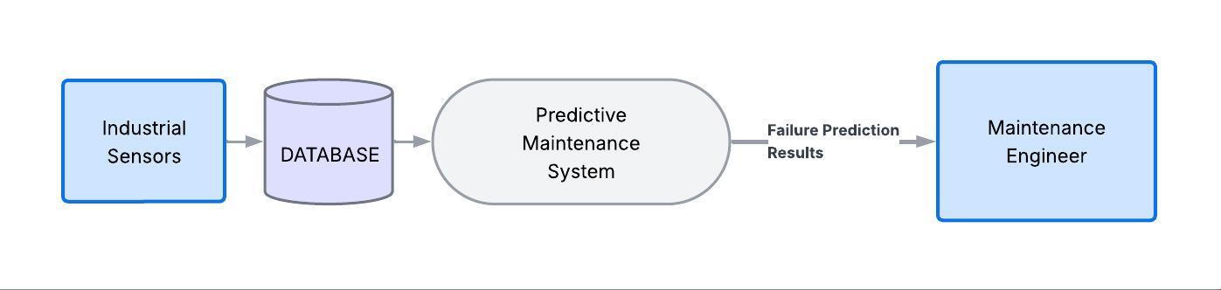
Level 0:

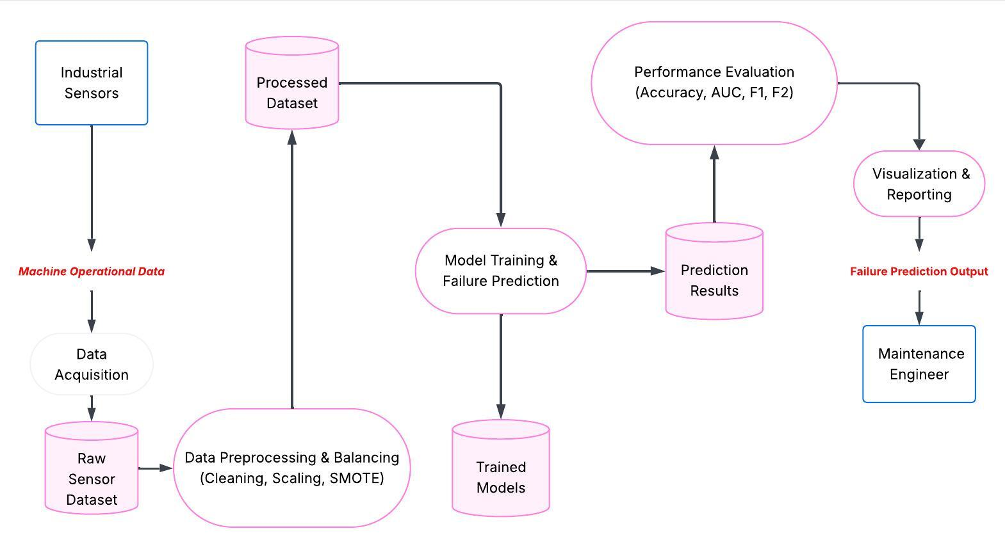
Level 1:

- Algorithm Used

- Data Preprocessing and Feature Engineering: This technique prepares industrial sensor data for machine learning by handling missing values, scaling numerical features using StandardScaler, and addressing class imbalance using SMOTE. It also includes correlation analysis and feature transformation to ensure reliable model performance and improved predictive accuracy.
- Principal Component Analysis (PCA): PCA is used for dimensionality reduction and variance analysis. It transforms correlated sensor variables such as temperature, torque, and rotational speed into principal components, helping to visualize data structure and identify dominant factors influencing machine failures.
- Supervised Machine Learning Models: Multiple classification algorithms including Logistic Regression, K-Nearest neighbours (KNN), Support Vector Machine (SVM), Random Forest, and XGBoost are implemented to predict machine failure (binary classification) and identify failure types (multi-class classification). Hyperparameter tuning is performed using GridSearchCV for optimal performance.
- Evaluation Metrics and Recall Optimization: The system uses Accuracy, AUC, F1-score, and F2-score to evaluate model performance. Special emphasis is placed on the F2-score to prioritize recall, ensuring that critical machine failures are not overlooked in industrial environments.
- Data Visualization and Model Interpretation: Visualization techniques such as correlation heatmaps, PCA plots, confusion matrices, and permutation feature importance are used to interpret model behaviour and understand key factors contributing to machine failure predictions.

- MILESTONE

Sr.no. | Project Activity | Estimated Start Date | Estimated End Date
1. | Project Allotment | 9/02/2026 | 9/02/2026
2. | Synopsis Creation | 10/02/2026 | 21/02/2026
3. | Synopsis presentation | 24/02/2026 | 24/02/2026

7. MEETING WITH SUPERVISOR

Date of the Meet | Comments by the Supervisor | Signature of the Supervisor
9/02/2026 | Initial discussion on Project
23/02/2026 | Discussed about algorithm
23/02/2026 | Start implementation as soon as possible

8. REFERENCES

- Subramaniam, M. R., & Mangu, S. "Predictive Maintenance: A Comprehensive Analysis and Future Outlook." Proceedings of the International Conference on Future Technologies (INCOFT), IEEE, 2023.
- Ghelani, D. "Harnessing Machine Learning for Predictive Maintenance in Energy Infrastructure: A Review of Challenges and Solutions." International Journal of Science and Research Archive, Volume 12, Issue 2, pp. 1138–1156, 2024. DOI: 10.30574/ijsra.2024.12.2.0525.
- Rosati, R., Romeo, L., Cecchini, G., Tonetto, F., Viti, P., Mancini, A., & Frontoni, E. "From Knowledge-Based to Big Data Analytic Model: A Novel IoT and Machine Learning Based Decision Support System for Predictive Maintenance in Industry 4.0." Journal of Intelligent Manufacturing, Volume 34, Issue 1, pp. 107–121, 2023. DOI: 10.1007/s10845-022-00960-x.
- Almobarek, M., Mendibil, K., & Alrashdan, A. "Predictive Maintenance 4.0 for Chilled Water System at Commercial Buildings: A Methodological Framework." Buildings, Volume 13, Issue 2, 2023. DOI: 10.3390/buildings13020497.

